Research Application for the Butterfly Biology Lab

Thanks for your interest in our lab. We are always looking for creative and motivated people who are willing to help out, and gain research experience in the lab. Undergraduates are an important and integral part of the lab, helping on a wide range of projects, from field work and animal care to behavioral observations and dissections. Many students help with existing projects, some students develop their own projects and several are involved in writing manuscripts for publication. There are many different opportunities for you to be involved in undergraduate research in the lab and contribute to science in a meaningful way!

If you are interested in research in the lab, you can check out our lab website (https://www.cbs.umn.edu/lab/emilies/) to get a general overview about what we do. There’s also a nice photospread of some of the recent work going on in the lab that will give you a good idea of some of the types of work we do over the summer: http://www.cbs.umn.edu/cbs-highlights/wings-change. You might even want to read some of our papers (links are available on the web site). This document provides some general guidelines for students and other volunteers looking for a research experience in the lab.

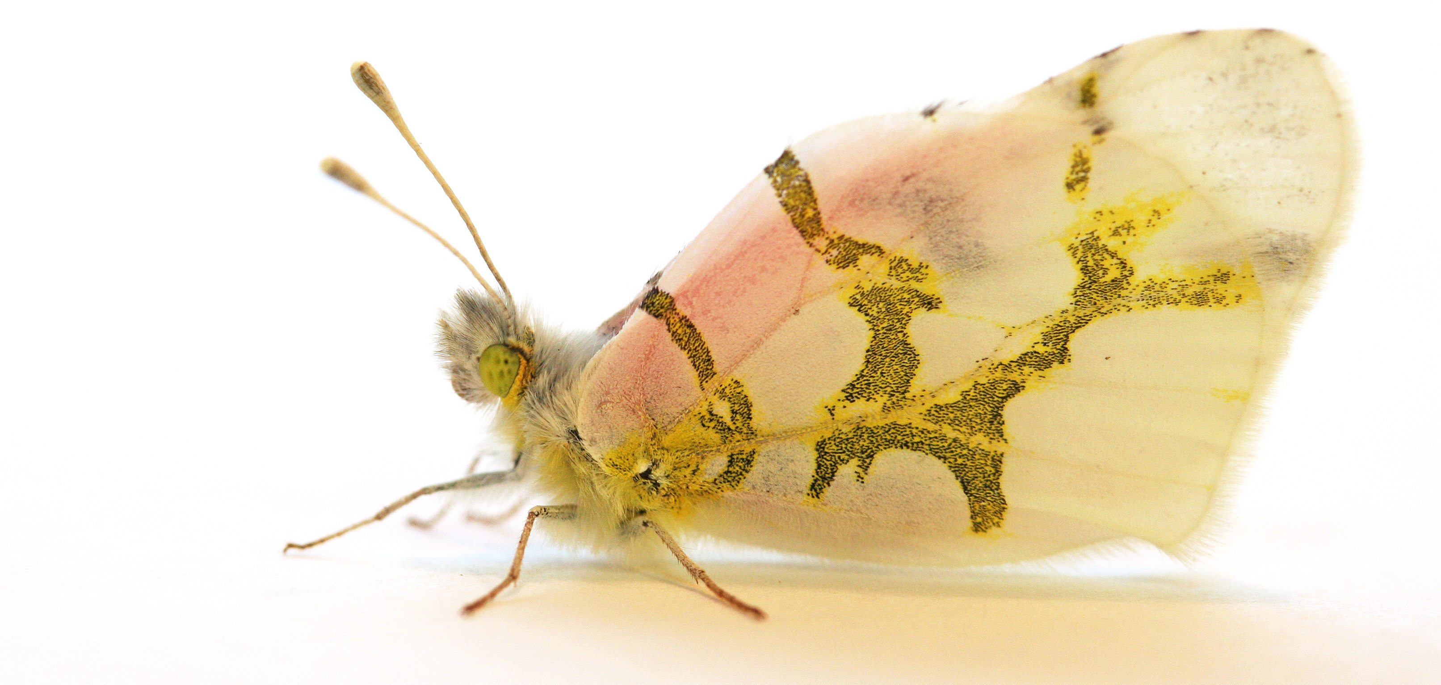

General Principles

First, it is often difficult for a single student to direct their own research project within the lab within the course of a single semester (or summer). This is because of the nature of our research: each experiment can take several months to several years to complete and requires a range of skills that take several months (or several years) to develop. But there are still many opportunities for you to learn significant research skills and be involved in meaningful research projects during your time in the lab. Students undertaking directed research should think of themselves as an important and integral part of a research program involving several different experiments and projects.

Second, research in our lab (as in many others) involves many different types of work, from fairly low-level work (like collecting and feeding animals) to the highest level of work (like designing experiments and writing scientific papers). All of these are important, but some kinds of work require more training than others. Students conducting research in the Butterfly Biology Lab should expect to participate in day-to-day experiment running and animal care if they choose to work in our lab. After being involved in a project for a while, there are opportunities for students to get involved in data analysis, manuscript preparation and presentations at the local or even national level.

Third, there are a number of possibilities for you to conduct research in the Butterfly Biology Lab. You can volunteer or take directed research credits, or you may be hired as an undergraduate research assistant during the summer (if funding is available). All of these forms of participation require the completion of this application. We generally encourage students to start out volunteering in the lab for at least several weeks (or a whole semester) before committing to directed research. If you are helping with an existing project in the lab, hours are generally fairly flexible. Generally you decide the hours you want to commit, and once your semester (or summer) schedule is worked out, you can choose times you regularly come to the lab to help out with projects.

Finally, for students taking directed research credit, your work should, of course, have some intellectual content. In addition, if you’re seeking credit for directed research you should produce something during your time in the lab, such as a written report, a statistical analysis of your results, or give a lab meeting. How you achieve this “intellectual content” and what you “produce” depends on your skills and interests. People in the lab can suggest ideas to you, but this should be a joint decision. It should be something that interests you, fits your skills and fulfills your educational goals.

Here are two suggestions about how you might contribute to our lab intellectually.
- Project-oriented. If you find that you’re interested in one of the on-going experiments or projects, you might, in consultation with lab staff, read about the issues behind the experiment, and identify a part of the experiment where you can play a role (e.g. data analyst, etc). In this model, you might, for example, perform a preliminary analysis of the data, or analyze some aspect of the data that we haven’t planned to consider. In this case, your product would be like a mini-paper, reporting the findings and suggesting further studies.

- Lab-oriented. Many issues and tasks in our lab apply to all experiments (animal care, growing plants), and you may find that you have keen interest in one of these issues. You might develop new techniques that improve the way we do things, or analyze the results of what we have done in the past. In this case, your product would be recommendations for improvement or the development of a new generally useful tool.

It often works best for you to work in the lab, doing general lab tasks, for a few weeks to a month before deciding which of these tracks to follow; because this will introduce you to the projects and general procedures of our lab.
Research Application

BUTTERFLY BIOLOGY LAB
using butterflies to study ecology, evolution, developmental plasticity
DEPARTMENT OF ECOLOGY, EVOLUTION & BEHAVIOR

This application is for prospective volunteers, directed research/directed studies applicants, and applicants for a summer research assistantship in the Butterfly Lab.

Please attach the following with this application:
- Resume: Make sure you have given details about your research and employment history.
- Transcript: This transcript can be a printout from your OneStop web transcript.
- Preliminary Schedule: Your preliminary schedule for the semester when you plan to volunteer, work, or take directed research.

Please send your application to Emilie Snell-Rood (email to emilies@umn.edu)

Check the box for the type of research work for which you are applying:

◻ Volunteer
◻ Work Study
◻ Directed Research
◻ UROP Project
◻ Paid Research Assistantship (if available)

Check the research project(s) topics you are most interested in:

◻ Nutrition of roadside plants for pollinators
◻ Plant mutagens and tolerance to novel mutagens in butterflies
◻ Butterfly courtship signaling in variable environments
◻ Limits to adaptive responses to toxins/stressors
◻ Adaptation to anthropogenic nutrient increases using Daphnia as a system
◻ Immune responses to multiple pathogens in butterflies
◻ I’d be interested in most any project in the lab
◻ I’d be interested in eventually developing my own project (ideas below)

NAME: ________________

STUDENT NUMBER:__________________________

PHONE:____________________________

E-MAIL:_____________________________

CLASS STANDING (circle one): freshman sophomore junior senior

ANTICIPATED GRADUATION DATE:___________

MAJOR:________________________ MINOR:___________________

GPA:___________

FOR WHICH SEMESTER ARE YOU APPLYING:_________________________

RESEARCH INTERESTS / PROJECT IDEAS:

SPECIAL SKILLS (Animal Handling/ Field Experience/Computer Programming):
HOBBIES, OTHER INTERESTS:

WHAT ARE YOUR PLANS FOR THE FUTURE (i.e. educational, professional)*

WHAT DO YOU HOPE TO GAIN FROM THIS RESEARCH EXPERIENCE?*

*There are no right or wrong answers to these questions, but your answers will help us to match you with the right projects and experiences in the lab.

